St James’ Catholic High School Music Lessons – Expression of Interest letter

Dear Parent/Carer

Your child has expressed an interest in starting music lessons, which are provided by Stockport Music Service.

The cost of a shared lesson is £85 per term and should you require an individual lesson these can be provided at £160 a term.

You will have the opportunity to hire a musical instrument (except keyboard and drums, which are available in school) from the Music Service at a cost of £60 per year.

Please return the slip below to the address above ASAP in order that we can arrange to send you an information pack, which contains a contract that needs to be completed, signed and returned to the above address by no later than 30 July, along with payment for the first term.

Should you require any further information then please contact the office on 483 7636.

Yours faithfully
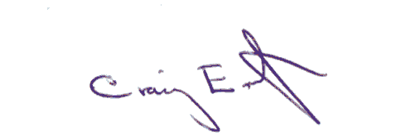

Craig Eastwood
Head of Stockport Music Service

Please return to the address above

St James’ Catholic High School – Expression of Interest in music lessons from Sept 2018

Name _________________________________Class ________________________________

I am interested in my child learning to play the ______________________________________,
please send me a pupil pack.

Cheques must be sent with the contract but will not be processed until lessons are guaranteed. If you do not have a cheque book, payment can be made over the phone.

Signed _____________________ Date________________ Tel no ______________________

Email _______________________________________________________________________

