Appendix 2
Information on School Uniform:

All students are expected to meet basic standards of uniform at all times. This includes:
- School tie and blazer must be worn at all times (unless a student is given specific permission to not wear them by a member of staff)

- Students must wear plain formal black leather or leather look school shoes, closed toe school style shoe with no studs or metal. Heels may not be higher than 2.5 cm. Fabric plimsoll type footwear is not permitted. No trainers or sports brands.

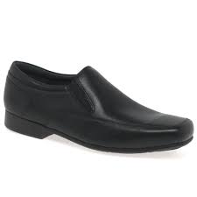
These are examples of acceptable types of shoes:
Boys
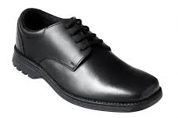
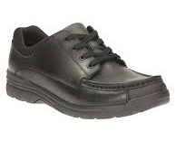

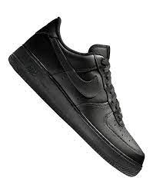
Shoes which are NOT acceptable: Please note these shoes are often marketed as School Shoes but they are not formal shoes as required and so although they may be made of leather, they would NOT be acceptable.

These are examples of acceptable types of shoe:
Girls
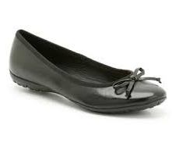

Examples of shoes which are NOT acceptable:
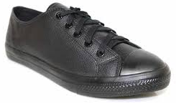

‘Kickers’ in any form are NOT permitted in school.

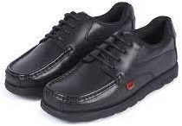
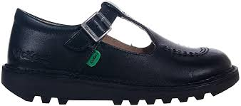

- Students must wear black trousers or navy pleated skirt (of an appropriate length and NOT rolled up to appear shorter).
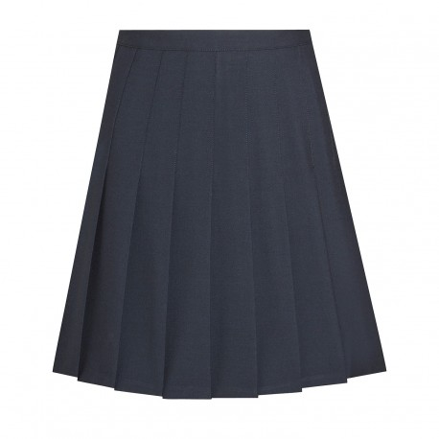

Skinny trousers or jeans are NOT permitted.

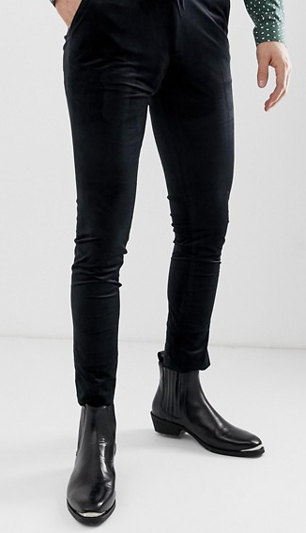

- Students must wear a white formal shirt which must be tucked in.
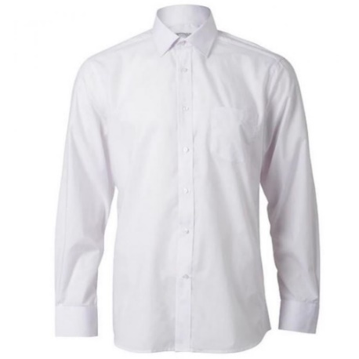

White casual/ designer shirts NOT permitted.

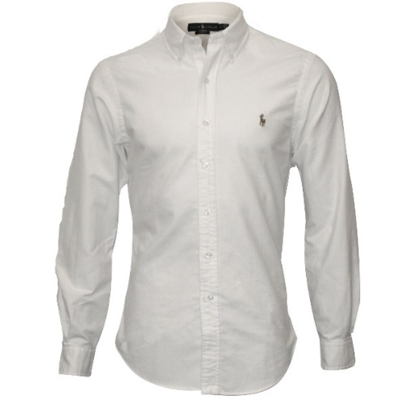
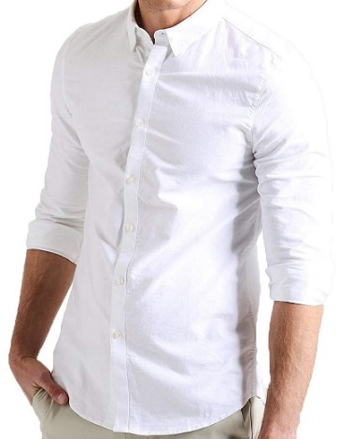

- Students are not allowed to wear coats in the school building. They may wear them in the areas outside but must then remove them upon entering school. Coats must be worn over the top of the school blazer and NOT underneath.

These are examples of acceptable types of coat:
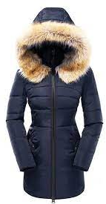
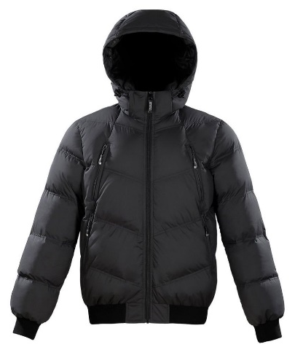

- Hoodies in any form are NOT permitted in school. Anyone student wearing one in school will be asked to remove it and this will be confiscated. Confiscated items must be collected by a parent or carer.
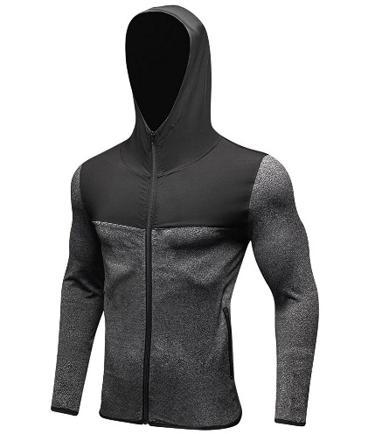
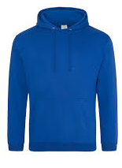
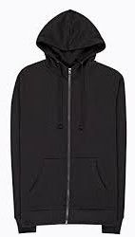

- For all students, hairstyles must be sensible, tidy and of a natural colour. Extreme hairstyles are forbidden. For example, shaved haircuts (less than a number 2) where the scalp is clearly visible or dyed hair an unnaturally bright colour, dipped dyed and ombre hair styles. If hair is tied back it should be with a plain coloured bobble. Any hair accessories should be plain and dark coloured.

These are examples of acceptable hair styles:

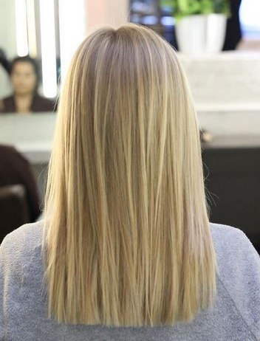
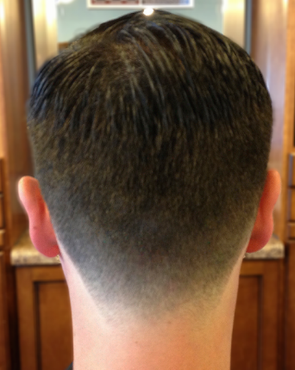
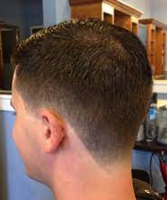

These are examples of extreme hair styles and are NOT permitted in school:

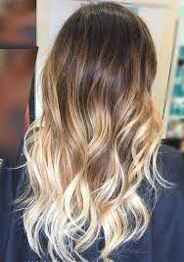
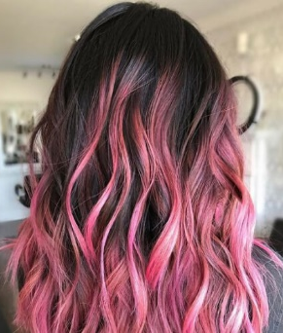
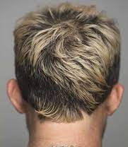
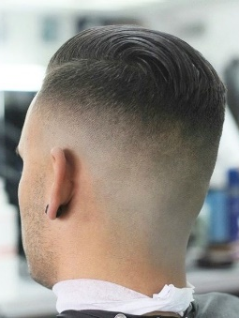

- Pupils must wear black or navy blue socks as part of their uniform and any other colour is NOT permitted. Girls can wear black / navy blue tights or black / navy blue socks one or the other but NOT together and socks must be worn underneath the knee.
- If pupils are wearing the navy blue jumper with school trim (optional) this must NOT be tucked in the school trousers or skirt and cannot be worn instead of the school blazer.
- Jewellery of any kind is not to be worn by pupils. We expect ALL pupils to have high standards of appearance and dress. Any member of staff who sees a pupil wearing jewellery should immediately request that it is removed and the item of jewellery should be confiscated. School will not be accountable for the loss, theft or damage to jewellery (in line with other banned items) and we will not investigate any such incidents. All confiscated items, including jewellery, will be put in an envelope and be placed in the school safe as soon as is practical. Confiscated items must be collected from the main reception by a parent or carer.

- Students are expected to wear little or no make-up and no fake tan. If students have excessive make-up they will be asked to remove it, if students are wearing fake tan they will be kept out of circulation during break and lunchtimes. Students must not have tattoos or other skin modifications.

The Headteacher and Assistant Headteacher Behaviour and Attitudes have responsibility for the uniform code of the school as agreed by Governors and their judgement is final on all matters of uniform. We would ask parents and carers to recognise this and be supportive of both the expectations and spirit of the uniform code to maintain high standards across the school.

The school has a clear uniform code and form tutors will make it clear to the students what our requirements are with respect to school uniform and general appearance as it is better that students are made aware of these requirements regularly than it being necessary to confront a pupil who has broken them. Regular infringement of the uniform rules should be reported to the appropriate Head of Year. However, if a pupil comes to school without appropriate uniform or has an extreme hairstyle this should be reported immediately to the Head of Year to decide on the suitable course of action. Students may be kept out of circulation when not in lessons so the rest of the school community do not see a drop in the school’s high standards and expectations.

